### Part 1

Part 1 of the Experiment compares the $LU$ decompositions of two matrices, $B$ and $C$ with and without pivoting. The decompositions can be seen below.

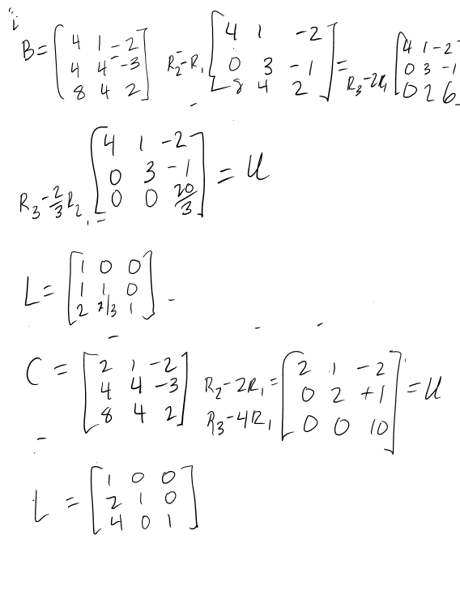

### 

Notably, without pivots both $L$ and $U$ are quite different. With the pivots, things get much closer, $L$ and $U$ differ by only one or two elements at most. There is a slight error in the pivotal decomposition for $B.$ In matrix $L$, the element $L_{33}$ should be a one not a zero, having a major diagonal consistent with the identity.Part 2



Part 2 of the experiment compares the increased accuracy of iterative refinement across single and double precision solutions to matrix systems using Matlab. The residuals of the solutions to randomly generated $n×n (10≤n≤2000)$ square matrices were computed using double and single precision values with the norms being plotted before and after two steps of iterative refinement. The results are show below.

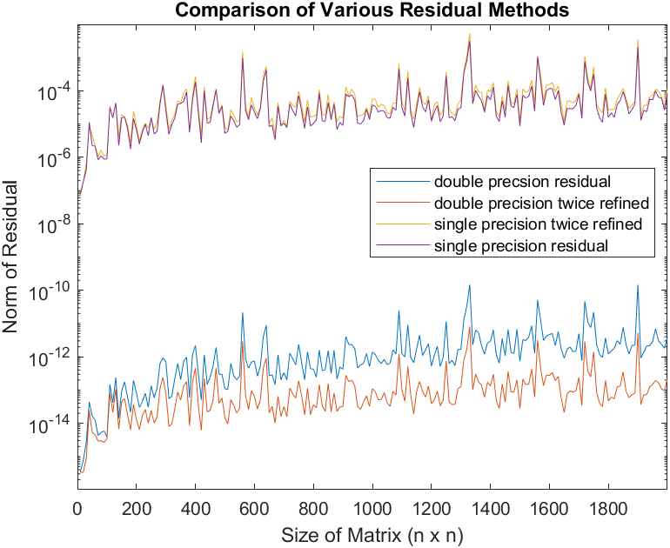

Interestingly, two steps of iterative refinement had little to no effect on the size of residuals in the single precision case. In fact, in many cases the residual was slightly bigger, meaning it negatively impacted accuracy. Iterative refinement appeared to have significant impact (2 orders of magnitude) on double precision values, particularly as $n$ increased.

### Part 3

Part 3 of the experiment investigates the behavior of ill conditioned Matrices. The flow of water through two very different materials gives this tridiagonal system of linear equations in which all the entries apart from the three diagonals shown are zero.

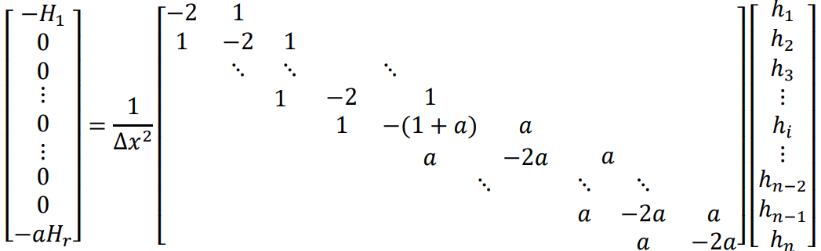

$Δx$ was fixed at 1, $a$ varied from $1×{10}^{-1}$ to $1×{10}^{-15}$, and $n$ varied from $21$ to $161$, $H_{1}=8$ and $H_{r}=4$. The condition number of the matrix was estimated using MATLAB’s built-in function $cond()$. Theoretically, the condition number should vary by $κ≈\frac{1}{C*a}$ solving for $C$ yields $C≈\frac{1}{κa}$. This is born out experimentally, results are shown in the table below.

|  |  |  |  |  |  |  |  |  |  |  |
| --- | --- | --- | --- | --- | --- | --- | --- | --- | --- | --- |
| **Condition**  **Number** | | **a values** | | | | | | | | **Avg. Constant** |
| 1.00E-01 | 1.00E-03 | 1.00E-05 | 1.00E-07 | 1.00E-09 | 1.00E-11 | 1.00E-13 | 1.00E-15 |
| **n values** | 21 | 4.10E+02 | 4.14E+04 | 4.14E+06 | 4.14E+08 | 4.14E+10 | 4.14E+12 | 4.14E+14 | 4.14E+16 | 2.42E-02 |
| 41 | 1.61E+03 | 1.62E+05 | 1.62E+07 | 1.62E+09 | 1.62E+11 | 1.62E+13 | 1.62E+15 | 1.62E+17 | 6.16E-03 |
| 81 | 3.62E+03 | 3.65E+05 | 3.65E+07 | 3.65E+09 | 3.65E+11 | 3.65E+13 | 3.65E+15 | 3.65E+17 | 2.74E-03 |
| 161 | 6.45E+03 | 6.49E+05 | 6.49E+07 | 6.49E+09 | 6.49E+11 | 6.49E+13 | 6.49E+15 | 6.49E+17 | 1.54E-03 |

Iterative refinement was also tested on the experimental data. The norms of residuals of the solutions are compared at each case of $n$ and $a$ with one, two or no additional iterative refinement steps taken. One step of iterative refinement reduced the norms of the residuals by roughly one order of magnitude, but a second appeared to have no major changes. **Results are available as a table on the following page**.

### Conclusion

This experiment provided insight into the (im)precision of computers and the limits of techniques to increase that precision. Specifically, if there is limited precision available for compute, additional iterative refinement may be a waste of resources. Also, even if double precision is available, certain real world situations may not benefit from unlimited additional refinement depending on the circumstances of the systems we’re working with. All results are taken from my personal machine running a 2nd Intel i5 processor on the MATLAB 2020 software. This experiment also continues to show the value in understanding the limitations and capabilities of computers for intense computations.

|  |  |  |  |  |  |  |  |  |  |
| --- | --- | --- | --- | --- | --- | --- | --- | --- | --- |
| **Norm of Residuals** | | **a values** | | | | | | | |
| 1.00E-01 | 1.00E-03 | 1.00E-05 | 1.00E-07 | 1.00E-09 | 1.00E-11 | 1.00E-13 | 1.00E-15 |
| **n values** | 21 | 8.88E-16 | 1.33E-15 | 1.78E-15 | 8.88E-16 | 1.33E-15 | 1.33E-15 | 8.88E-16 | 2.66E-15 |
| 41 | 8.88E-16 | 1.33E-15 | 1.78E-15 | 1.33E-15 | 1.78E-15 | 8.88E-16 | 1.78E-15 | 2.66E-15 |
| 81 | 1.78E-15 | 1.78E-15 | 1.33E-15 | 8.88E-16 | 1.78E-15 | 1.78E-15 | 1.78E-15 | 8.88E-16 |
| 161 | 1.78E-15 | 1.78E-15 | 1.78E-15 | 1.78E-15 | 1.78E-15 | 8.88E-16 | 2.66E-15 | 1.78E-15 |
|  |  |  |  |  |  |  |  |  |  |
| **One Refinement Residual Norms** | | **a values** | | | | | | | |
| 1.00E-01 | 1.00E-03 | 1.00E-05 | 1.00E-07 | 1.00E-09 | 1.00E-11 | 1.00E-13 | 1.00E-15 |
| **n values** | 21 | 4.44E-16 | 8.88E-16 | 1.33E-15 | 8.88E-16 | 4.44E-16 | 4.44E-16 | 8.88E-16 | 1.78E-15 |
| 41 | 8.88E-16 | 8.88E-16 | 4.44E-16 | 8.88E-16 | 8.88E-16 | 8.88E-16 | 8.88E-16 | 8.88E-16 |
| 81 | 8.88E-16 | 8.88E-16 | 8.88E-16 | 8.88E-16 | 8.88E-16 | 8.88E-16 | 1.78E-15 | 8.88E-16 |
| 161 | 8.88E-16 | 8.88E-16 | 8.88E-16 | 8.88E-16 | 8.88E-16 | 8.88E-16 | 8.88E-16 | 8.88E-16 |
|  |  |  |  |  |  |  |  |  |  |
| **Two Refinement Residual Norms** | | **a values** | | | | | | | |
| 1.00E-01 | 1.00E-03 | 1.00E-05 | 1.00E-07 | 1.00E-09 | 1.00E-11 | 1.00E-13 | 1.00E-15 |
| **n values** | 21 | 6.66E-16 | 8.88E-16 | 1.33E-15 | 8.88E-16 | 4.44E-16 | 4.44E-16 | 8.88E-16 | 8.88E-16 |
| 41 | 1.78E-15 | 8.88E-16 | 4.44E-16 | 8.88E-16 | 8.88E-16 | 1.78E-15 | 8.88E-16 | 8.88E-16 |
| 81 | 8.88E-16 | 1.78E-15 | 8.88E-16 | 8.88E-16 | 8.88E-16 | 8.88E-16 | 8.88E-16 | 8.88E-16 |
| 161 | 8.88E-16 | 8.88E-16 | 8.88E-16 | 8.88E-16 | 8.88E-16 | 8.88E-16 | 8.88E-16 | 1.78E-15 |